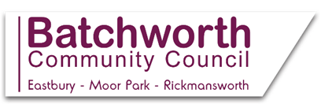
Appointment of Clerk to Batchworth Community Council
Salary Band: £27,358 - £30,756 pro-rata (within NJC SCP 30-34) increasing to £27,905 - £31,371 from 1 April 2019
Part-time: 22½ hours per week including attending evening meetings
If you have a real passion and commitment to public service then Rickmansworth, Moor Park and Eastbury needs you to support this forward thinking and energetic Council and enable it to develop and deliver timely, quality and innovative services to our local communities.
You will be highly motivated, enthusiastic and community focused bringing good administrative and management skills. In return we offer flexibility in hours and excellent nationally based terms and conditions of employment.
You will ensure that all legal, statutory, financial and other governing provisions relating to the Council are observed and that all Council meetings are properly administered. You will implement the Council’s decisions whilst developing healthy working partnerships with key local and national bodies.
Applicants should ideally have previous experience working in, or have knowledge of, local government, although training will be provided. The ability to communicate well is essential both spoken and written.
To apply: Please email your CV and Supporting Statement (with Appointment of Clerk to BCC in the email subject line) to clerk@batchworth-ecc.gov.uk
The closing date for the receipt of applications Friday 15 February 2019
Interviews will take place on week commencing Monday 25 February 2019
Further information:
- Job Description
- Person Specification
- Budget for 2019/20
- Background Information
For an informal discussion, please contact Mike Kennedy (Interim Clerk) on 01923 590201
Please note, due to the volume of applications we receive, we are unable to inform all applicants as to whether they have been shortlisted for interview. Therefore, if you have not heard from us within 2 weeks of the closing date, please assume your application has been unsuccessful.

